Social impact reporting template

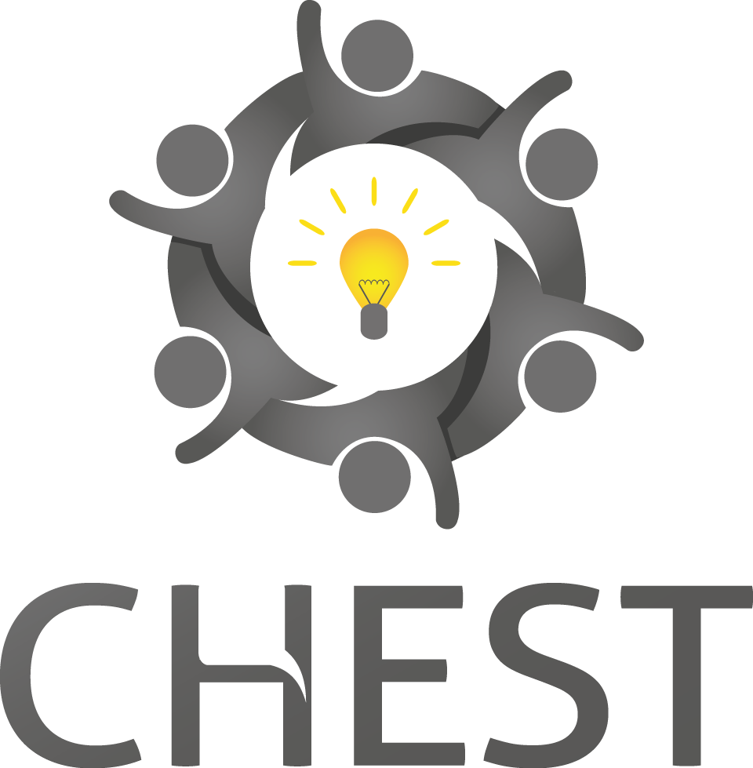

Developed by the CHEST project, which is supported by the
Seventh Framework programme of the European Commission

Table of contents

0. Purpose of this report 3
1. Implementation of organizational structure 5
2. Implementation of your solution approach 7
3. Measuring your Social Impact 12

- Purpose of this report
The structure of this report is partly based on the format suggested by the Social Reporting Standard SRS (http://www.social-reporting-standard.de/en) standardizing the regular work documentation of organisations run by social entrepreneurs, non-profit organisations, and other organisations with a social purpose (such as social businesses) – for funders, investors, partner organisations, and the public. The catalogue of Key Performance Indicators assessing the social impact is based on the methodological framework of the IA4SI project. This template is aiming to support your initiative in reporting your social impact towards your stakeholders such as venture philanthropists, social banks, or partners. It provides a simple structure facilitating to present your project in a concise and yet complete way. It also helps you to assess your concept and the logic chain behind the societal problem you are addressing and the suitability of your approach. Throughout the report you should be brief and to stick to the recommended lengths indicated for each section.

Ch. 1 | Implementation of organizational structure | In the first section you should describe a brief description of the organisational structure of your project, namely the organisations, individuals, and cooperation partners involved in carrying out your project.
Ch. 2 | Implementation of your solution approach | Section 2 will take a closer look at your “market” by researching in depth the societal problem you’re addressing and outlining explicitly how your solution is aiming to solve it.  The reader should be able to  - understand the problems you have identified,  - what you assume to be their causes and  - how you intend to address these causes.  The identification of the actual or imminent problem which is to be remedied represents a key aspect of impact-oriented reporting. For this purpose, it is important to describe the social problem at hand. In this part you should also describe your specific activities during the reporting period and develop an initial plan to scale your prototype.
Ch. 3 | Measuring your Social Impact | Section 3 focuses on the social impact you aim to achieve. You should describe the social changes for the individual target groups which can be observed as a consequence of your activity. As measuring social impact can be challenging, this section of the report will guide you to define a set of key performance indicators (KPIs) for your project. First, you’ll find a pre-defined list of indicators which are recommended for any project in the field of Digital Social Innovation. These indicators cover 3 different dimensions:  - Online community building  - Access to information  - Knowledge sharing  Second, you will be guided in the process of defining your project’s specific set of additional indicators that meet your individual needs. These KPIs should be selected to cover your main impact area(s):  - Social impact areas (including ecological impacts)  1.1 Impact on community building and empowerment  1.2 Impact on information  1.3 Impact on ways of thinking, values and behaviours  1.4 Impact on education and human capital  1.5 Impact on employment  1.6 Impact on environment  1.7 Impact on civic and political participation  1.8 Impact on policies and institutions  - Economic impact areas  2.1 Users’ economic empowerment  2.2 The economic value generated by the project  For each indicator you should define your baseline (your starting point value) and then set realistic target values. In order to facilitate the involvement of your target users in co-designing your prototype and to assess a sub-set of your KPIs, we finally recommend you to carry out an early stage test of your envisioned prototype / concept with your target group(s).

- Implementation of organizational structure
This section aims to provide a brief description of how you implement your project. You should describe the maturity of your project, its organizational structure as well as the individuals, and cooperation partners involved in implementing your prototype.

  - Maturity of your project
It is helpful for the reader to understand the current state of your application development, e.g. by referring to the following phases.
- Idea/seed phase: No solution has been implemented yet.
- Pilot phase: Phase in which various proposed solutions are tested.
- Growth phase: The proposed solution has been implemented by the organisation, usually first on a local or regional basis. The focus is on spreading the proposed solution, either by way of own growth or via cooperation with partner organisations.
- Mature/establishment phase: The organisation is known for its proposed solution and has reached financial sustainability. The target groups are reached on a regular basis.
- Expansion and renewal phase: The organisation turns to additional or different objectives. Reasons may be that its approach is not (or is no longer) sufficient for solving the social problem or because the approach is losing relevance (e.g. because certain services are now included in regular government services or because the context of the problem has changed).
Recommendation: Stay between 100 and 200 characters.
[…]

  - Organizational structure
In this section, please describe the structure of how you implement your project, which tasks are fulfilled by which unit as part of the overall activity. Please specify how many individuals are involved in the activity and indicate whether they are permanent employees, freelancers, or volunteers.
Recommendation: Stay between 500 and 1000 characters.
[…]
  - Key personnel
The purpose of this section is to provide the reader with an overview of the key individuals involved. Please decide freely which and how many individuals are relevant. In addition to providing biographical details, please consider the following aspects:
- Motivation
- Relevant experience and skills, for instance in relation to initiating activities or establishing companies/organisations
- Leadership experience
- Expert knowledge of the particular subject area, experience with regard to the target groups
- Specific qualifications relevant to the approach
Recommendation: Stay between 1000 and 3000 characters for each person.
[…]

  - Partnerships, cooperations, and networks
The partnerships and cooperations in which your project is involved are key parts of your positioning and effectiveness. Please provide details on the following aspects:
- Partners (individuals, organisations, other Digital Social Innovation initiatives, public authorities, memberships in networks, government and EU workgroups, and professional associations, etc.)
- Subject and goal of the partnership
- Contractual basis of the partnership (e.g. contractual agreement, memorandum of understanding, verbal agreement)
- Strategic significance of the partnership
Please also report details concerning relevant changes which have taken place during the reporting period.
Recommendation: Stay between 500 and 2000 characters for each partnership.
[...]

- Implementation of your solution approach
Please describe the context of the problem you intended to solve and your specific approach to solving the problem. The reader should be able to understand the problems you have identified, what you assume to be their causes and how you intend to address these causes. The identification of the actual or imminent problem which is to be remedied represents a key aspect of impact-oriented reporting. For this purpose, it is important to describe the societal problem at hand (“children in Germany do not exercise sufficiently”), rather than stating a social concern or demand (“children in Germany should exercise more”).
We define a “societal problem” as any social need that you intend to address and for which you have created an activity, programme, project or product. Social problems include ecological and environmental problems.
In any of the following sections a dedicated focus lies on the new insights you have gained during the reporting period. Please describe in which ways your understanding of the problem has changed during this project. Wherever possible, please highlight your lessons learned over time.
2.1 The societal problem
2.1.1 Description of the problem
In order to be able to understand the specific solution proposed, the reader must be aware of your understanding of the social problem, its context, and the underlying causes. Please elaborate on the following points:
- Which specific problem did you intent to solve? The social problem should be described as specifically as possible. If several problems can be identified, they should be prioritized based on importance.
- Who is affected by the problem? Please describe in detail who is affected by the problem and how so.
- How has your perception / understanding of the problem changed during the reporting period (lessons learned)?
- How has the social problem itself evolved over time? What is the current situation (your baseline scenario)? How will the problem develop in the future if no action is taken?
- What are the underlying causes of the problem? Please describe interdependencies of different causes.
Describing interdependencies between different causes is crucial. Only with this knowledge will readers understand your specific approach to solving the problem.
Recommendation: Stay between 2000 and 5000 characters.
[…]

2.1.2 Scale of the problem
Readers can more easily assess the relevance of the problem and the effectiveness of your proposed solution if you provide information regarding the problem’s scale:
- How many people are affected by the problem? Please describe the European dimension of the problem. Depending on the type of problem you are dealing with, it may be useful to provide additional information concerning the scale of the problem (e.g. size of the area, percentage or number of people affected in the case of environmental protection activities).
- Has the scale of the problem changed during the reporting period? If possible, please also provide estimates for the likely future development.
- What social consequences have already occurred, and what costs have been incurred by society as a result? What do you expect to be the consequences and costs if the problem remains unsolved?
Any information should be as specific as possible and quantified where possible. Please list any sources used.
Recommendation: Stay between 2000 and 5000 characters.
[…]

2.1.3 Previous approaches to solving the problem
It is likely that other attempts have already been made to solve the social problem. Please describe how and with what success others have previously attempted to solve the problem. This helps the reader to understand and assess your proposed solution. You can also explain why and in what respect these previous approaches have not been sufficient for solving the problem. If there have not been any previous attempts to solve the problem, it can be useful to explain why this might be the case.
Recommendation: Stay between 500 and 2000 characters.
[…]

2.2 Your approach to solving the problem

2.2.1 Solution approach – what do you intend to achieve and where do you start?
Please describe the ideal state of the situation that you aim to achieve: What is your long-term objective which provides the central motivation for your activity? Has this objective changed during the reporting period?
Please also provide a brief description of your fundamental approach. In section 2.1.1 you have explained the causes of the problem. This section asks you to detail which point in the causal chain leading to the problem your project addresses – and what in general you intend to achieve. What is the added value you offer to the respective target groups and in which form (products, services, tools, etc.)? This brief description of your impact chain enables the reader to understand how your project contributes to solving the problem.
Recommendation: Stay between 2000 and 5000 characters.
[…]

2.2.2 Target groups
Here you describe who you intended to reach with your activity. Your direct target group comprises those individuals your proposed solution addresses directly such as the participants of a workshop. In addition, there may be individuals who benefit indirectly from your activity such as the children of parents who take part in a parenting programme. Your target group may also include influencers and intermediaries such as journalists or teachers you approach in order to ensure that your idea is spread and your objectives are met.
There may be several different groups of individuals or institutions on all three levels. Please focus on those groups of individuals that are particularly important.
Please provide the following information for your target groups:
- Who belongs to the respective target group?
- How large is the respective target group?
- What are the concerns and goals of the members of the respective target group? Which of these concerns or goals can be realized or attained by way of your activity?
- If possible, please highlight new insights you gained with regard to your target groups during the report period: Did you identify new target groups in reporting period? Did your target groups change in some ways?
Recommendation: Stay between 500 and 1000 characters for each target group.
[…]

2.2.4 Activities and work performed
In appendix 1 of this document you’ll find a set of templates to describe your specific activities during the reporting period (comprising the resources employed and the work performed by your team and partners). Please use these templates to provide the following information:
- A concise description of the work performed for each work package
- Describe any management concerns and activities to recover the situation
- Detail any publications, publicity or other dissemination activity.
- Summarise the project progress against deliverables, noting any discrepancies against the Project Plan and action to recover situation if necessary

Recommendation: The length of this section largely depends on the structure of your work so a specific recommendation is not suitable. You should stick to brief, but concise descriptions mentioning all important aspects of your work.
[...]

2.3 Implementing your route to market
A central part of your project is the implementation of your route to market. Please describe how you intend to spread your proposed solution. The central questions you should answer here are:
- How you intent to take your prototype to the next level?
- Which sources of financing are you going to use?
- How are you planning to reach your target groups?

Please focus on the mechanisms used to spread your approach. In many cases, however, you will not be able to implement your solution in other locations yourself. Instead, you may collaborate with local or regional partners or approach local providers and ask them to implement your approach independently. Some projects spread certain activities or services. Others enable, educate or empower third parties to use a method themselves. Or they spread an attitude or an idea. Please describe as detailed as possible, what exactly you spread. There is a wide range of possibilities for spreading and scaling solutions – from the publication of knowledge and experience to licensing or expansion of your own activity by growing your organisation. You can use the following examples for your description:
- Open distribution: You provide experience and knowhow to third parties either for a fee or free-of-charge but do not influence the local implementation (except through advice and/or assistance). The following are three strategies which are frequently used for open distribution:
  - Publication of results via brochures, manuals, web sites, or public presentations
  - Training and consulting
  - Definition of standards, possibly also accreditation
  - Open source / creative commons licensing models for your prototype / final solution
- License and/or social franchise models: You collaborate with independent partners who are responsible for implementing the activity locally, but are bound by a (contractual) agreement. For instance, partners are permitted to use your knowhow, brand, and other intellectual property. At the same time, they may be required to take part in trainings or even undergo regular certification, to meet quality standards or pay fees or charges for services that you provide.
- Networks and cooperation approach: Your own activity can also be spread by forming or joining a network or by entering into cooperation with other organisations in the market.

Recommendation: Stay between 2000 and 5000 characters.
[…]
- Measuring your Social Impact
In chapter 2 you have described the societal problem you are addressing. In this section we ask you to report on the social impact you anticipate for the individual target groups as a result of your solution – and the extent to which you succeed in realizing your objectives. To understand the concept of social impact, the distinction between resources used, work performed, and impact has proven useful:
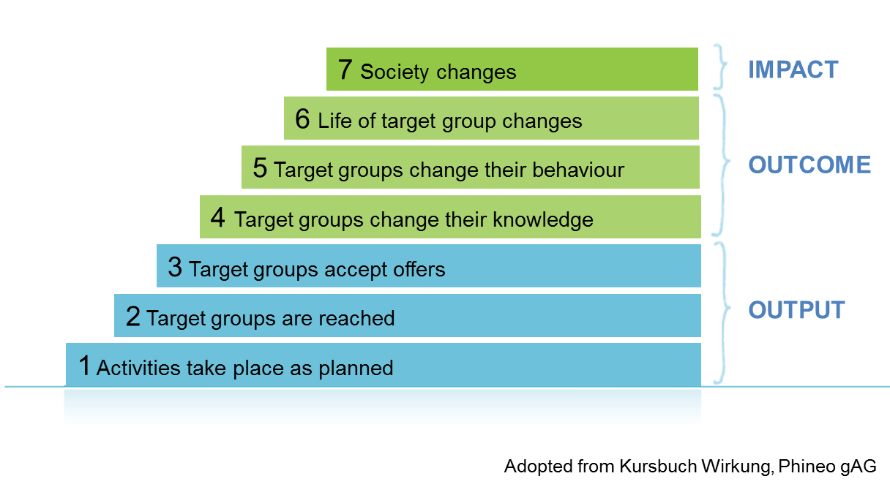
3.1 Your expected social impact
Impacts are defined as the social changes which can be observed as a consequence of the output of your activity. Ecological impacts are also considered as social impacts in this context. Impact can affect the individuals directly addressed. For instance, changes in the behaviour of parents attending parental training. Changes (impacts) may also affect some groups indirectly such as the children of parents who have participated in parental training. In certain cases, it is also possible to specify results on the level of society. For instance, it may be possible to quantify a re-socialisation programme’s cost savings for the whole economy due to a particularly low relapse rate or the carbon dioxide savings that result from an energy-saving campaign.
Please describe the social impact you anticipate for the individual target groups as a result of your activity!
Recommendation: Stay between 2000 and 5000 characters.
[…]

Based on this description you should derive a set of useful indicators (Key Performance Indicators, KPIs) which help you to measure your social impact – and to set your specific goals for these indicators. In many cases, it will be difficult to directly measure the impact of your activity. However, appropriate indicators that are known to be closely connected with your intended effects will allow you to make statements about the effectiveness of your activities – even if you are not able to ultimately prove causality, it will be helpful to explain why you derive the effectiveness of your activity from certain indicators. In order to facilitate this process we have pre-defined a list of indicators recommended for all project in Digital Social Innovation:

Table 1: Common indicators for all CHEST projects (see also appendix 2)
Dimensions | Indicators | Variables | Baseline value | Target value | Measured value
ONLINE COMMUNITY BUILDING | User involvement in prototype evaluation / test usage | Number and description of target groups involved in co-design process
 |  | Number of users involved in co-design process
 |  | Ratio between men and women involved
 |  | Ratio between young, adult and old people involved
ACCESS TO INFORMATION | Project self-evaluation of its capability to influence information asymmetries | Project self-evaluation of its capability to influence information asymmetries (e.g. access to sources of information that represent a range of political and social viewpoints, access to media outlets or websites that express independent, balanced views, etc.)
 | Number of tools/activities developed by the project for influencing information asymmetries | Number of tools/activities developed by the project for influencing information asymmetries
KNOWLEDGE SHARING | Sharing through social media channels | Number and description of communication channels addressed
 |  | Quantified measure of followers on selected social media channels (e. g. twitter followers, facebook friends, etc.)

In addition to this list of recommended indicators you should also define those indicators that best suit your project (from the catalogue of additional indicators, appendix 3). In order to do so, you should first choose your primary and your secondary social impact area and then identify at least 3 different indicators for each impact area that are most suitable for your project. If suitable, you can also choose an economic impact area and similarly identify at least 3 different indicators for that area. The social and economic impact areas are listed below:
- Social impact areas (including ecological impacts)
1.1 Impact on community building and empowerment
1.2 Impact on information
1.3 Impact on ways of thinking, values and behaviours
1.4 Impact on education and human capital
1.5 Impact on employment
1.6 Impact on environment
1.7 Impact on civic and political participation
1.8 Impact on policies and institutions
- Economic impact areas
2.1 Users’ economic empowerment
2.2 The economic value generated by the project

In appendix 3, you will find an extensive catalogue of potential indicators for each impact area. If non or not enough of the indicators listed in appendix 3, you can also define your own indicator(s) according to your needs.

For each indicator, please define a target value you aim to achieve at the end of reporting period and fill the following table with your set of indicators for each impact area!

Impact area: […]
Dimensions | Indicators | Variables | Baseline value | Target value | Measured value
[…] | […] | […] | […] | […] | […]
 |  | […] | […] | […] | […]

While some indicators will be only quantifiable once your prototype is finished, others can be assessed already during the development phase. One way to allocate their values is an early concept or prototype test / evaluation. One key prerequisite to achieve a high impact in developing Digital Social Innovations is the user-centred design involving your target users right from the project start (co-design). Following an iterative development cycle, you should carry out such a concept test / prototype evaluation involving your target users as early as possible and repeat them whenever appropriate. There are many different and easy to use techniques available to carry out such early-stage evaluations (user analysis, concept test, etc.) taking place even before a running system is available (using click-demos, mockups or paper) – for example:
- Scenario-based testing
(http://www.cs.pomona.edu/classes/cs181f/supp/scenariotest.html)
- Wizzard-of-Oz prototyping (http://www.ucc.ie/hfrg/projects/respect/urmethods/wizard.htm)
- Paper prototyping
(http://www.paperprototyping.com/what.html)
- Video Prototyping
(http://www.ucc.ie/hfrg/projects/respect/urmethods/video.htm)
Choose an applicable methodology (for possible methods other than the few stated above please take a look at http://www.ucc.ie/hfrg/projects/respect/urmethods/methods.htm) and carry out an evaluation/test of your envisioned prototype/concept testing a suitable sub-set of your indicators (selecting some but not all indicators identified for your project under section 3.2) – you should at least provide following information (Dimension: Online Community Building, Indicator: User involvement in prototype evaluation / test usage):

- Number of target groups involved in co-design process
- Number of users involved in co-design process
- Ratio between men and women involved
- Ratio between young, adult and old people involved

Please provide a brief summary of the evaluation results and describe those areas (indicators) for which the prototype will be well suited – and the week spots you found where further improvements in the requirements or early design will be necessary. The goal here is not to show that your idea is already perfect. On the contrary: As your project is new and innovative, it is very likely that in interacting with your target groups by testing your idea with them you will encounter unforeseen critical issues. Please describe these issues and provide your ideas to address them. In order to help you solve these problems you should also involve your community providing you with feedback and ideas so please be brief but clear in your description.

Recommendation: In addition to assessing the values of the KPIs you measured, please stay between 3000 and 5000 characters in the description of your evaluation.

[…]

Appendix 1: Templates for Summary of Progress

Repeat for each work package:
Work Package Number :

Actual Starting month :
Predicted / Actual End month :

Work Package Objectives:

Description of work this period

Progress towards the Deliverables for this Work Package

Summarise any problems you have encountered, and how they have been overcome
Description of planned activity for next reporting period

Project Management And Dissemination
Summarise any management concerns and activities to recover the situation.

Detail any publications, publicity or other dissemination activity.

Deliverable Status
Summarise the project progress against deliverables, noting any discrepancies against the Project Plan and action to recover situation if necessary.
Use Green text for completed, Red for late and Blue for items due in the next quarter.
Ref | Title | WP | Due Date | Actual Date | Comments
D1.1

Appendix 2: List of recommended indicators to monitor the social impact of all Digital Social Innovation initiatives

Below you’ll find a list of indicators aiming to monitor the social impact of all Digital Social Innovation initiatives.

Dimensions | Indicators | Variables
ONLINE COMMUNITY BUILDING | User involvement in prototype evaluation / test usage | Number and description of target groups involved in co-design process
 |  | Number of users involved in co-design process
 |  | Ratio between men and women involved
 |  | Ratio between young, adult and old people involved
ACCESS TO INFORMATION | Project self-evaluation of its capability to influence information asymmetries | Project self-evaluation of its capability to influence information asymmetries (e.g. access to sources of information that represent a range of political and social viewpoints, access to media outlets or websites that express independent, balanced views, etc.)
 | Number of tools/activities developed by the project for influencing information asymmetries | Number of tools/activities developed by the project for influencing information asymmetries
KNOWLEDGE SHARING | Sharing through social media channels | Number and description of communication channels addressed
 |  | Quantified measure of followers on selected social media channels (e. g. twitter followers, facebook friends, etc.)

Appendix 3: Catalogue of project specific indicators to monitor your social impact

Below you’ll find a catalogue of possible indicators to assess different areas of social impacts. Not all of them are suitable for your project. Please choose your primary and your secondary social impact area and then identify at least 3 different indicators for each impact area that are most suitable for your project. If applicable, you can in addition also choose an economic impact area and similarly identify at least 3 different indicators for that area.

- Social impact areas (including ecological and political impacts)
1.1 Impact on community building and empowerment (additional indicators)
Dimensions | Indicators | Variables
ONLINE COMMUNITY BUILDING | Change in time spent on the platform by users | Time spent by the users, on average
 |  | Change in time spent on the platform by users
ONLINE COMMUNITY EMPOWERMENT | Number of groups spontaneously created by the users | Number of groups spontaneously created by the users
 | Project capability to influence trust among users | Self-assessment on project capability to influence trust among users
 |  | Sharing of personal data among users
LOCAL COMMUNITY BUILDING | Project self-assessment of its capacity to foster the creations and the enlargement of local communities/groups | Project self-assessment of its capacity to foster the creations and the enlargement of local communities/groups
 | Project capacity to provide to local communities/groups instruments for better organise themselves | Project self-assessment of its capacity to provide to local communities/groups instruments for better organise themself
LOCAL COMMUNITY EMPOWERMENT | Number of events organised by the the project addressing local communities | Number of participants to events organised by the project addressing local communities
 | Project capability to influence local communities in terms of social inclusion and non-discrimination | Project self-evaluation of its capability to make local communities more inclusive
 |  | Number of project activities/outputs dedicated to fostering social inclusion and non-discrimination in local communities

1.2 Impact on information (additional indicators)
Dimensions | Indicators | Variables
ACCESS TO INFORMATION | Typology of information- data available on the platform | Typology of information- data available on the platform - selection from a list including:  • Articles/long post/structured content  • Short post/status updated  • Forum discussions  • Forum entries  • Images  • Videos  • Other contents
 | Quantity of information available | Number of information for each typology selected in the previous question at the time of the assessment
QUALITY OF INFORMATION | Instruments provided by the project allowing users to verify the quality of the information he/she access | Number of instruments provided allowing users to verify the quality of the information he/she access to

1.3 Impact on ways of thinking, values and behaviours (additional indicators)
Dimensions | Indicators | Variables
CHANGES IN OPINIONS / WAYS OF THINKING | Topics where opinion change is expected to happen | Topics where opinion change is expected to happen
 |  | Detailed description of topic and subtopics
 | Activities performed by the project in order to achieve the expected change in users opinions, values and behaviours | Activities performed by the project in order to achieve the expected changes in users opinions, values and behaviours
 | Number of people participating in the activities | Number of people participating in the activities
CHANGE IN BEHAVIOURS | Topics where changes in behaviours are expected to happen | Topics where changes in behaviours are expected to happen

1.4 Impact on education and human capital (additional indicators)
Dimensions | Indicators | Variables
TRAINING PROVIDED BY THE PROJECT | Training efficiency | Hours of training provided by the project
 |  | Number of persons trained
 |  | Topics covered by training activities
 |  | Budget allocated to training
 | Tools for education/training developed by the project | Number of tools for education/training developed by the project
 |  | Description of tools for education/training developed by the project
IMPACT ON HUMAN CAPITAL | Impact on users eSkills | Number of activities supporting the acquisition of digital competences, digital literacies competences, eSkills and the reduction of digital divide
 |  | Number of participants to activities supporting the acquisition of digital competences, digital literacies competences, eSkills and the reduction of digital divide
 | Project self-evaluation of its capability to support the personal development of its users | Project self-evaluation of its capability to support the personal development of its users
 |  | Description of project's support to the personal development of its users
CHANGE IN TRAINING CURRICULA, EDUCATIONAL POLICIES AND PERSONAL INVESTMENTS IN EDUCATION | Project self-evaluation of its capability to influence changes in training curriculum of secondary and higher education | Project self-evaluation of its capability to influence changes in training curricula of secondary and higher education
 | Project self-evaluation of its capability to influence changes in educational policies | Project self-evaluation of its capability to influence changes in educational policies
 |  | Description of project influence on educational policies
 | Project self-evaluation of its capability to influence its users investment in education | Project self-evaluation of its capability to influence its users investment in education
 |  | Description of project influence on users investments in education

1.5 Impact on employment (additional indicators)
Dimensions | Indicators | Variables
IMPACT ON JOB CREATION (DIRECTLY DEVELOPED BY THE PROJECT) | New job places generated | Number of persons recruited specifically for the project
 | Number of persons recruited specifically for the project that will continue to work after the end of the project | Number of persons recruited specifically for the project that will continue to work after the end of the project
 | Impact on woman employment | Rate of woman in the project
 | Number of new job places generated (or expected to be generated) by the project outputs | Number of new job places generated (or expected to be generated) by the project outputs
 | Number of spin-off/start-ups developed as a result of the project | Number of spin-off/start-ups developed as a result of the project

1.6 Impact on environment (additional indicators)
Dimensions | Indicators | Variables
PROJECT IMPACT ON ENVIRONMENTAL BEHAVIOURS RELATED TO THE GREENHOUSE GASES ISSUE | Project self-assessment of its capability to provide easier access to innovative solutions for low carbon technologies | Project self-assessment of its capability to provide easier access to innovative solutions for low carbon technologies
 | N. of compensation activities performed by the users since their engagement with the project (perception of the project vs. users questionnaire) | N. of compensation activities performed by the users since their engagement with the project according to the project
PROJECT IMPACT ON BEHAVIOURS RELATED TO AIR POLLUTION RELATED TO TRANSPORT ISSUE | Project self evaluation of contribution to the increase in users' sensitivity towards the issue of air pollution related to local, everyday transport | Project self evaluation of contribution to the increase in users' sensitivity towards the issue of air pollution related to local, everyday transport
 | Project self-assessment of its capability to provide easier access to innovative solutions for a sustainable transport choices | Project self-assessment of its capability to provide easier access to innovative solutions for a sustainable transport choices
PROJECT IMPACT ON ENVIRONMENTAL BEHAVIOURS RELATED TO THE WASTE ISSUE | Project self assessment of its capability to provide easier access to waste management technologies | Project self assessment of its capability to provide easier access to waste management technologies
 | N. of waste reduction activities performed by the users since their engagement with the project | N. of waste reduction activities performed by the users since their engagement with the project according to the project
 | Project self evaluation of the increase in users’ sensitivity towards the waste issue (e.g. participation to community-based reusing/recycling initiatives, etc.) | Project self evaluation of the increase in users’ sensitivity towards the waste issue (e.g. participation to community-based reusing/recycling initiatives, etc.)
PROJECT IMPACT ON ENVIRONMENTAL BEHAVIOURS RELATED TO THE SUSTAINABLE CONSUMPTION ISSUE | Increase of green / local / ethical products purchased by users in relation to start of the project- in percentage | Increase of green / local / ethical products purchased by users in relation to start of the project- in percentage
 | N. of promotion of sustainable consumption activities performed by the users since their engagement with the project (perception of the project vs. users questionnaire) | N. of promotion of sustainable consumption activities performed by the users since their engagement with the project according to the project
 | N. of green labels or certifications for products or services promoted by the initiative | N. of green labels or certifications for products or services promoted by the initiative
PROJECT IMPACT ON ENVIRONMENTAL BEHAVIOURS RELATED TO THE BIODIVERSITY ISSUE | N. of biodiversity conservation initiatives supported by the users | N. of biodiversity conservation initiatives supported by the users
 | Project self-assessment of its capability to provide easier access to biodiversity conservation technologies / methodologies | Project self-assessment of its capability to provide easier access to biodiversity conservation technologies / methodologies

1.7 Impact on civic and political participation (additional indicators)
Dimensions | Indicators | Variables
IMPACT ON CITIZENS/USERS POLITICAL AWARENESS | Project self evaluation of changes in the time spent by users in getting informed about local, national and international political issues | Project self evaluation of changes in the time spent by users in getting informed about local, national and international political issues
 | Project self assessment of changes in the time spent by users in persuading friends, relatives or fellow workers about social/political issues | Project self assessment of changes in the time spent by users in persuading friends, relatives or fellow workers about social/political issues
 | Changes in the social/political topics addressed by users | Changes in the social/political topics addressed by users
IMPACT ON CITIZENS/USERS CIVIC PARTICIPATION | Instruments developed by the project offering new channels/way for civic participation | Number of instruments developed by the project offering new channels/way for civic participation
 | Project self evaluation of its capability to increase the number of citizens participating to civic-society organisation | Project self evaluation of its capability to increase the number of citizens participating to civic-society organisation
 | Project self evaluation of its capability to increase the time spent by citizens in participating to civic-society organisation | Project self evaluation of its capability to increase the time spent by citizens in participating to civic-society organisation
 | Project self evaluation of its capability to increase the number of bottom-up/grassroots actions | Project self evaluation of its capability to increase the number of bottom-up/grassroots actions
IMPACT ON CITIZENS/USERS POLITICAL PARTICIPATION | Instruments developed by the project offering new channels/way of political participation | Number of instruments developed by the project offering new channels/way of political participation
 | Project self-evaluation of its capacity to increase citizens/users participation to national and local election | Project self-evaluation of its capacity to increase citizens/users participation to national and local election
 | Project self-evaluation of its capacity to increase citizens/users participation in: signature campaigns, boycotts and manifestations | Project self-evaluation of its capacity to increase citizens/users participation in signature campaigns, boycotts and manifestations
 | Project capability to improve political participation of citizens belonging to group at risk of discrimination | Project self evaluation of its capability to improve political participation of citizens belonging to group at risk of discrimination

1.8 Impact on policies and institutions (additional indicators)
Dimensions | Indicators | Variables
PROJECT CAPABILITY TO INFLUENCE POLICIES AND INSTITUTIONS | Number of policy recommendations produced by the project | Number of policy recommendations produced by the project
 | Number of policy makers and institutions representatives aware of the policy recommendations | Number of policy makers and institutions representatives aware of the policy recommendations
 | Meetings/conferences organised/attended for influencing policy-makers | Number of meetings/conferences organised/attended for influencing policy-makers
 |  | Number of policy makers/institutions represented in the meeting
 | Project self-evaluation of its capability to influence institutions/governments transparency | Project self-evaluation of its capability to influence institutions/governments transparency
 | Project capability to influence parties/democratic processes transparency | Project capability to influence parties/democratic processes transparency
 | Policies/regulations/laws changed or updated by the project | Number of policies/regulations/laws changed or updated by the project
 | Number of institutions created or changed by the project | Number of institutions created or changed by the project
USERS IMPACT ON POLICIES AND INSTITUTIONS | Project self-evaluation of its capability to influence the capability of citizens/users and civic society organisations of influencing policies | Project self-evaluation of its capability to influence the capability of citizens/users and civic society organisations of influencing policies
 | Number of policy recommendations/documents/petitions produced by users | Number of policy recommendations/documents/petitions produced by users thanks to the use of the project outputs
 | Project evaluation of users capability to influence institutions/governments transparency | Project evaluation of users capability to influence institutions/governments transparency
 | Project evaluation of users capability to influence parties/democratic processes transparency | Project evaluation of users capability to influence parties/democratic processes transparency
 | Number of policies/regulations/laws changed or updated by project users | Number of policies/regulations/laws changed or updated by project users
 | Number of institutions created or changed by project users | Number of institutions created or changed by project users

- Economic impact areas
2.1 Users’ economic empowerment (additional indicators)
DIMENSION | INDICATOR | VARIABLE
IMPACT ON ACCESS TO FINANCE | Project self-evaluation of its capability to increase the access to finance of its users | Project self-evaluation of its capability to increase the access to finance of its users
 |  | Total Funding distributed
 |  | Type and description of instruments for increasing access to finance
 | Impact through crowdfunding | Money attracted by the project through crowdfunding
 |  | Project self-evaluation of improving investment risk diversification opportunities for the users of the project through crowdfunding
IMPACT ON ENTREPRENEURSHIP AND INCOME GENERATION FOR THE USERS | Project self-evaluation of its capability to support the creation of entrepreneurial initiatives by users | Project self-evaluation of its capability to support the creation of entrepreneurial initiatives of its users
 | Number of enterprises or business ideas developed by the project users | Number of enterprises or business ideas developed by the project users
 |  | Instruments stimulating entrepreneurial activities
 | Number of test beds provided by the project supporting the users for testing business ideas | Number of test beds provided by the project supporting the users for testing business ideas
 | Project self-evaluation of its capability of improving the support to users for diversifying income resources | Project self-evaluation of its capability to improve user support in diversifying income resources
 | Project self-evaluation of its capability of increasing the incomes of the users | Project self-evaluation of its capability of increasing the incomes of the users
 | Project self-evaluation of its capability of increasing the resilience of its users to cope with crises | Project self-evaluation of its capability of increasing the resilience of its users to cope with crises

2.2 The economic value generated by the project (additional indicators)
DIMENSION | INDICATOR | VARIABLE
ECONOMIC RESULTS | Project self-evaluation of increasing the resource pooling of the users | Project self-evaluation of increasing the resource pooling of the users
 | Cost saving related to resource pooling | Cost-saving related to resource pooling
 | Percentage of use of shared resources | Percentage of use of shared resources
 | Monetary value of shared resources | Monetary value of shared resources
BUSINESS MODELS | Business Models | Business Models
 | Project self-evaluation of being able to generate a new business model | Project self-evaluation of being able to generate a new business model
 | New market opportunities for partners | New market opportunities for partners
 | Number of business collaborations | Number of business collaborations
COMPETITIVENESS AND EXPLOITATION | Project competitors | Project competitors
 | Project self-evaluation of its impact on the capability of the project team to keep pace with competitors | Project self-evaluation of its impact on the capability of the project team to keep pace with competitors
 | Number of persons able to be dedicated to exploitation and innovation transfer | Number of persons able to be dedicated to exploitation and innovation transfer
 | Number of activities for the transfer of each project output | Number of activities for the transfer of each project output

IA4SI – Impact Assessment for Social Impact (www.ia4si.eu) is a research project supported by the Seventh Framework programme of the European Commission. The IA4SI methodological framework is licensed under a Creative Commons Attribution-NonCommercial-ShareAlike 3.0 Unported License.
This set of impact indicators is based on the methodological framework developed by the IA4SI project (www.ia4si.eu). You can find the full set along with further explanations under http://ia4si.eu/wp-content/uploads/2014/11/D%202%201_methodology_1.1_301114.pdf The IA4SI methodological framework is licensed under a Creative Commons Attribution-NonCommercial-ShareAlike 3.0 Unported License.

